Foods that are Natural Painkillers
If your pain is small to moderate, try skipping pills and let nature provid you with natural painkillers. These 19 foods are natural cures and can be used to alleviate many types of pain… its your body experiment.
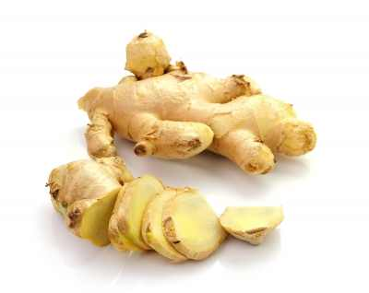
Muscle Pain – Ginger
Danish researchers found that regular consumption of ginger could reduce chronic muscle and joint pains, as well as swelling and stiffness within just a couple of months. The credit goes to the main ingredient in ginger – Gingerol, which inhibits the production of pain-inducing hormones. A teaspoon of dried ginger or 2 teaspoons of fresh ginger every day will do the trick.

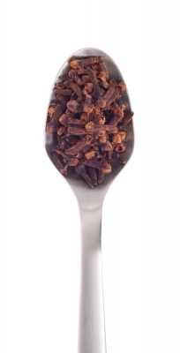
Toothaches – Cloves
Powdered cloves are a known home remedy for toothaches and gingivitis. Furthermore, a recent research from the University of California proved it scientifically by isolating the active ingredient that reduces the pain. It is an organic compound called eugenol – a powerful natural anesthetic. ¼ teaspoon every day will help keep your heart healthy, and scientists are saying that it also aids in stabilizing blood-sugar levels and even starts lowering cholesterol levels within three weeks.

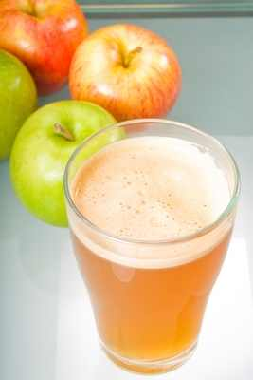
Acid Reflux – Apple Cider Vinegar
If heartburn constantly plagues you, you can stop them with apple cider vinegar. The active ingredients in the vinegar that treat reflux are malic acid and tartaric acid, which quicken digestion and help your body break down fats and proteins. Faster digestion means fewer chances for the stomach to overflow with acids, causing the reflux. By adding just a tablespoon of apple cider vinegar to a cup of water before every meal can prevent acid reflux within 24 hours.

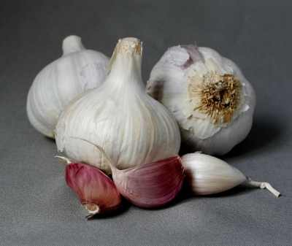
Earache – Garlic
Often referred to as “nature’s antibiotics”, garlic indeed possesses powerful anti-inflammatory qualities. Experts from the Mexico School of Medicine claim that applying two drops of warm garlic oil into the ear can cure an ear infection in five days. Garlic contains minerals such as selenium, germanium and sulfur, all are very toxic to most kinds of bacteria. To make your own garlic oil, slowly cook (do not boil) three garlic cloves in half a cup of olive oil for two minutes. Filter the oil and use it as instructed (make sure it’s not too hot). The oil can keep for up to two weeks in the fridge.

Headaches and join pains – Cherries

Michigan State University found that the daily consumption of a bowl of cherries is highly beneficial for people who suffer from headaches and various joint inflammations. Anthocyanin is the pigment that gives cherries their bright red color. It is also a powerful anti-inflammatory, ten times more powerful than ibuprofen or aspirin. Anthocyanin actively paralyzes the enzymes that cause tissue inflammation, making cherries the perfect treatment. Eating about 20 cherries every day will do the trick.


Stomachaches – Fish
Indigestion, irritable bowel syndrome, enteritis – all of these can be treated by eating fish. Many a research have shown that Omega3 fatty acids found in fish can actively reduce stomach cramping and enteritis. In some cases, Omega3 was found to be as effective as prescription medicine. The fatty acids aid in maintaining the general health of the digestive system thanks to their anti-inflammatory properties. 1 pound of fish per week is enough to support the digestive system. The fish richest in Omega3 are salmon, tuna, herring, mackerel, sardines, and trout.

PMS – Yogurt
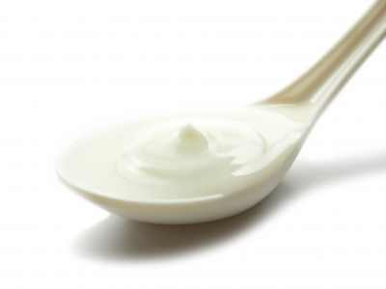
80% of women suffer from PMS-related pains before and during their periods. The reason for the pain is the nervous system’s sensitivity to the changes in estrogen and progesterone levels. A study conducted at Columbia University found that eating two servings of yogurt daily can reduce the intensity of PMS pains by almost 50%. Yogurt is rich in calcium, a mineral that naturally soothes the nervous system, thus preventing painful symptoms despite the hormonal changes.

Chronic Pains – Turmeric
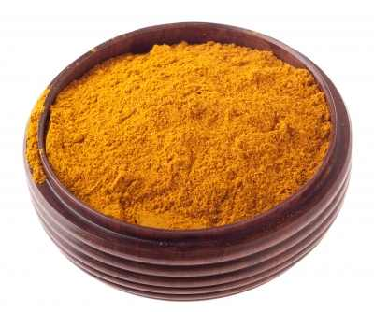
Turmeric was found to be three times more powerful than ibuprofen, aspirin, and naproxen. Researchers from Cornell University found that turmeric can heal up to 50% of people suffering from arthritis and fibromyalgia. The active ingredient in turmeric – curcumin, paralyzes the enzyme that causes serial pain. A ¼ teaspoon of turmeric every day will reduce your chronic pains considerably.

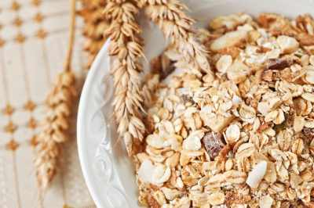
Endometriosis – Oats
When the tissue that normally grows inside the uterus grows outside the uterus, it may cause a severe and painful inflammation that drags on long after the end of the period. Luckily, an oats-rich diet can reduce up to 60% of the pains within six months. The reason is that oats don’t contain gluten, which can induce inflammation in many women.

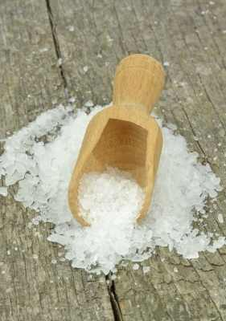
Ingrown Toenails and Toothaches – Salt
An ingrown toenail is a common ailment that affects millions of people around the world. Luckily, it’s easily treatable by using salt-water. Stanford University researchers found that soaking your feet in salt water can heal ingrown-related infections in just four days. Salt is antibacterial and anti-inflammatory, so adding just a teaspoon to a cup of warm water, and then add it to your foot bath twice a day until the infection is gone. Additionally, dentists recommend gargling with salt water to treat and prevent gingivitis. Finally, gargling with salt water can also help when you’re suffering from a throat infection.

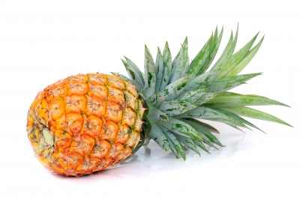
Indigestion – Pineapple
Pineapples are a delicious tropical fruit that is rich in protein-breaking enzymes. These enzymes help the body with the digestion processes, speeding it up and reducing stomach pains that come from gas buildups. Researchers at Stanford University found that one cup of fresh pineapple every day can treat pain caused by gas within 72 hours.

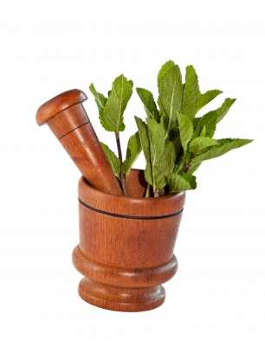
Muscle Pains – Mint
Cramped muscles can be painful for months, especially if they originate from incorrect posture or reoccurring overexertion. A hot bath with ten drops of mint oil, three times a week, are 25% more effective than prescription drugs. The hot water help relax and loosen the muscles while the mint oil soothes the aching nervous system. Such treatment will also help reduce the frequency of future pains.

Backaches – Grapes
In a study conducted at the University of Ohio, researchers found that one cup of fresh grapes per day can help improve blood flow to the damaged tissue in the back, sometimes within as little three hours. The spine is highly dependent on the nutrients and oxygen in the blood, making eating grapes a highly beneficial act.

